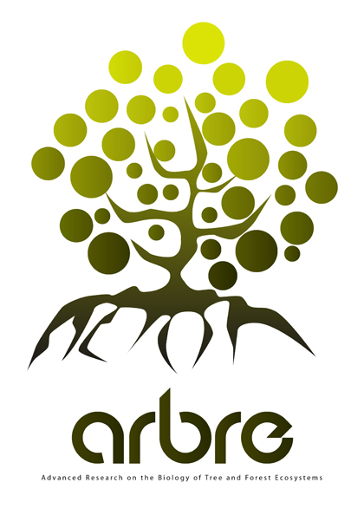 | Lab of Excellence ARBRE  Advanced Research on the Biology of TRee and Forest Ecosystems
Call for Proposal 2013 – Research projects

Project Title:

Project Leader:
Co-applicants:

A) Executive Summary of the Project (1 page)

B) Research proposal (10 pages)

Specific Objectives (1 page)
Background information and rationale for proposed research (2 pages)
Description of proposed research (3 pages)
Scientific Information (including novelty of the project)
Technical Information
Available Resources
Technical Challenges
Socio-economic impact assessment
GANTT Chart

Benefits to the Labex (2 pages)
Anticipated benefits and Socio-economic Research
Ethical, Environmental, Economic and Social Issues
Stakeholder Engagement/Facilitating Knowledge Translation To End-Users

Research Team (2 pages)
Competence of the PI’s to perform this work
Interactions between Labex teams

Management (Coordination, Data and Resource Sharing, Communication, Outreach)
Community Interest/International networking

Preliminary Financial Information
Salaries
Consumables (including equipement <4000€)
INRA Center Platforms
Travel

References
Biographical Sketch (CV’s) of PI’s (with link to Google Scholar MyCitation)

