Annexe 1 : a) Trame de rédaction pour les projets de recherche

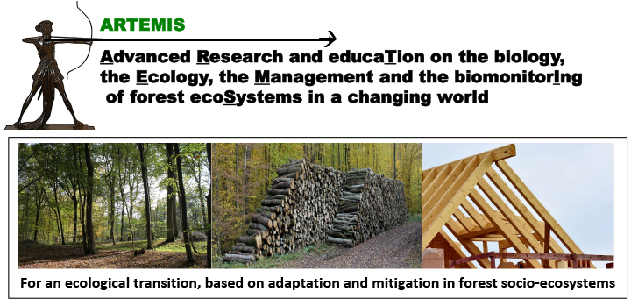 | Programme Interdisciplinaire ARTEMIS  Appel à projets 2025 | 

Call for Proposals 2025
INNOVATIVE RESEARCH PROJECT (PROJET INNOVANT)

Deadline March 27, 2025

Project Title:
Acronym:
Project Leader (name and Research Department):
Co-applicants (names and Research Department):
ARTEMIS operational challenge (OC) concerned:
Other ARTEMIS OC(s) concerned:
Start and end dates of the project: | XX to XX 2025. or XX 2025 to XX 2026
Confidential reviewing: yes / no

Executive summary (1/2 page max.)

Research proposal (10 pages max.), including:

Context and background information (1 page max.)
Rationale for proposed research and specific objectives (1 page max.)
Description of proposed research (3 pages max.)
Scientific Information (including novelty of the project) Technical Information
Available Resources
GANTT Chart

Project positioning according to the different operational challenges (cf site web ARTEMIS)

Benefits to ARTEMIS (1/2 page max.)
Anticipated scientific and socio-economic benefits
Stakeholder engagement/Facilitating knowledge translation to end-users and/or citizens
Research teams and management (1 page max.) including expertise of the PI’s to perform this work

Positioning in national and international networking (1/2 page max.)

Financial Information (1/2 page max. each). All costs should be indicated Tax Free.
Please include the funding plan (document excel ‘PFI_ARTEMIS.xlsx’)

Expense type | Euro
Functioning and Travel expenses
Master 2 grant
Subcontracting
Salaries
Small equipment (<800 Euros)
Requested or current matching funds (Agreenskills, ANR, PEPR, Région Grand-Est…)
Total

Mandatory
Please send your application in word format to ARTEMIS-PgI@inrae.fr and the name and address of five referees with no conflict of interest (no publication or common project during the last five years).

