Annexe 1 : c) Trame de rédaction pour les projets de formation/education/SAPS*

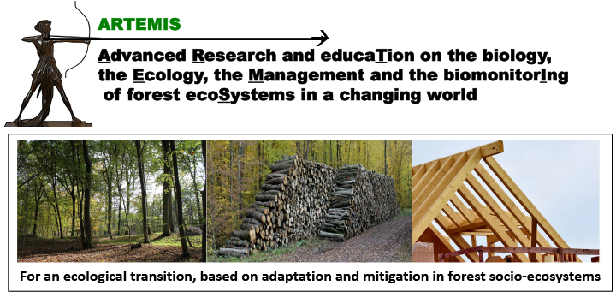 | Émergence du Programme Interdisciplinaire ARTEMIS  Appel ‘Graines d’Artemis’ (GA_2024) | 

Call for Proposals 2025
EDUCATION, FORMATION, SAPS* PROJECT (PROJET EDUCATION, FORMATION, SAPS)

Deadline March 27, 2025
Project Title:
Acronym:
Project Leader (name and Research Department):
Co-applicants (names and Research Department):
ARTEMIS operational challenge (OC) concerned:
Other ARTEMIS OC(s) concerned:
Start and end dates of the project: | XX to XX 2025. or XX 2025 to XX 2026
*SAPs: science avec et pour la société= science with and for society
Executive summary (1/2 page max.)

Education/formation/SAPS proposal (6 pages max.), including:

Type of event | ☐ Summer school ☐ Formation ☐ Other
Scope of the event | ☐ local ☐ National ☐ International
Expected date | ……
Expected duration | …..
Place | …..
Expected number of participants | …..
Editing of a support of communication (article, book, chapter, website) | ☐ oui ☐ non
Context and background information (1 page max.)

Rationale for the proposal and specific objectives (1 page max.)

Description of the proposal including available resources and benefits for the ARTEMIS community and LUE education/formation/SAPS sector (2 pages max.)

Project positioning according to the different operational challenges (cf site web ARTEMIS)

Project teams (1 page max.) including expertise of the PI’s to perform this work
Positioning in the LUE, Regional, and National networking (1/2 page max.)
Financial Information (1/2 page max. each). All costs should be indicated Tax Free.
Please include the funding plan (document excel ‘PFI_ARTEMIS.xlsx’)

Expense type | Euro
Functioning and Travel expenses
Master 2 grant
Subcontracting
Salaries
Small equipment (<800 Euros)
Requested or current matching funds (Agreenskills, ANR, PEPR, Région Grand-Est…)

Mandatory
Please send your application in word format to ARTEMIS-PgI@inrae.fr and the name and address of five referees with no conflict of interest.

